`
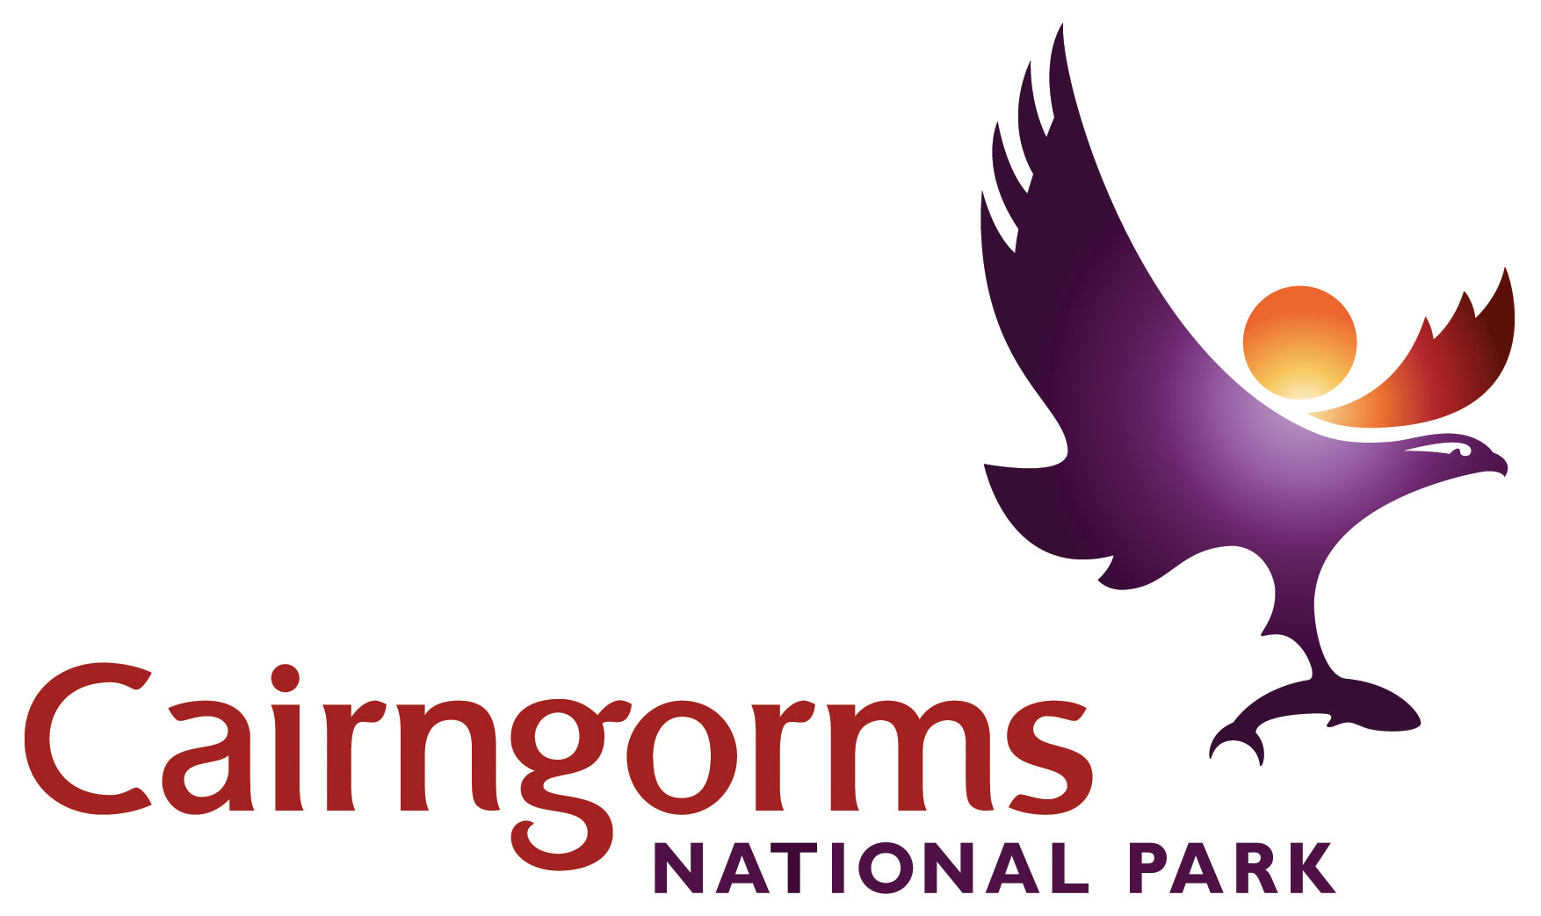

Cairngorms National Park
Outdoor Learning Travel Grant Scheme 2016/17

Application Form

- SCHOOL/ GROUP INFORMATION

School/ Group Name
Address
Post Code |  | Telephone Number
Contact email address
Teacher/Group Leader Name
Number of students /group members |  | Age of students / group members (approx)
Has your school/group visited the National Park before? | Yes No | If yes, when was this?  And did they use a ranger service? | Insert year  Yes No
Has your school received a CNP travel grant before? | Yes No

- SITE INFORMATION AND TRAVEL COSTS

Location for activities | see Guidelines for suggested sites  Include name of National Nature Reserve – see guidelines
Ranger service or site staff | Is Ranger Service or other staff support being provided for your visit? | Yes  No |  | Name of the ranger service / site staff you have been in contact with?
Proposed date of visit
Cost of transport, eg bus hire |  |  | Please provide us with estimated costs,  Exclude VAT if you can claim it back

If visit is not linked to the Curriculum, please skip to Section 4

- CURRICULAR INFORMATION
What activities will take place?

Subject or Topic area to be studied (must have natural / cultural environment link)

Which particular areas of the Curriculum are you studying, linked to the visit? (Specific CfE contexts and content rather than just broad attainment outcomes)

What do you expect the students to learn from their visit to the National Park? (include reference to the National Park)

Would you be able to go on this trip without funding support? | Yes  No  Please comment

- NON-CURRICULUM LINKED VISITS

Please tell us more about your group / clients.  (see Applicants section in Guidelines) | What is the make-up of your group?  What barriers or disadvantages does your group experience in accessing the National Park?
Please give a general outline of your planned itinerary
What would you like your group to learn/benefit from their trip to the National Park?

Would you be able to go on this trip without funding support? | Yes  No  Please comment

- PAYMENT DETAILS

Please provide your bank details for payments to be paid direct to your account
Bank Sort Code |  | Account Number
Account Name

OR if you would prefer to be reimbursed by cheque, please name the organisation to which the cheque should be made (please note we cannot make payment to individuals).

Name of organisation
Postal address

- SUBMITTING YOUR APPLICATION

Please send your completed application form:

By email to: learning@cairngorms.co.uk

By post to: Elspeth Grant, Education & Inclusion Officer, CNPA, 14 The Square, Grantown-on-Spey, PH26 3HG

Confirmation of your application will normally be made by email.

Please remember you must apply for your grant and it must be agreed BEFORE your visit.

