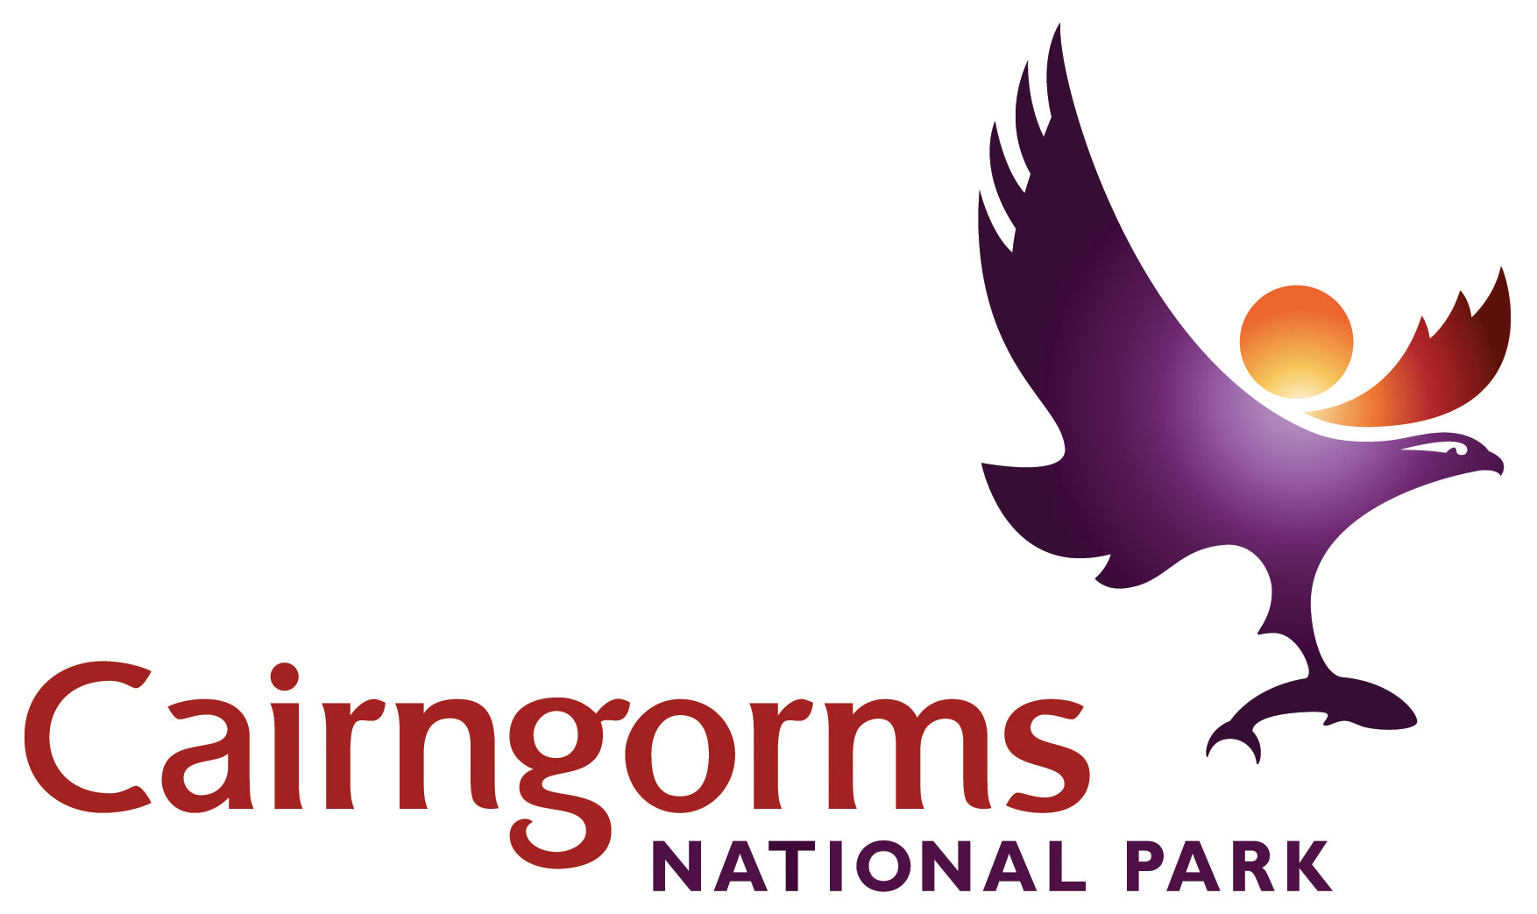

Cairngorms National Park
Outdoor Learning Travel Grant Scheme 2018/19
Guidelines

Applicants
a) Schools in Scotland (in and outwith the CNP)
b) Voluntary and community groups in Scotland. This includes groups and intermediaries who support and work with people experiencing some form of disadvantage e.g. on account of their age, gender, race, health, disability, social or economic reasons etc.

Priority will be given to:
- schools and groups from areas of multiple deprivation including urban areas near to CNP such as Inverness, Perth, Dundee and Aberdeen.
- those who have not visited the National Park or worked with a National Park ranger service previously.
- groups that support people with disabilities, young people, ethnic minorities and those who experience economic disadvantage or health inequality.

Eligible costs
This travel grant scheme may fund up to 75% of the total transport costs for visits based on the number of criteria met. Up to a maximum of £200.
- Eligible costs apply to transport to and from school or group meeting place to Cairngorms National Park e.g. bus or minibus hire. Only one trip per school is eligible.
- Visits must take place before 31st March 2019. Invoices / proof of payment must be received no later than 31st March 2019 and must show the date the service was used.
- Grants cannot be awarded retrospectively. You must apply for your grant and it must be agreed before your visit.

Activity
The activity applied for should, where applicable:
- Take place in the Cairngorms National Park including the nine National Nature Reserves.
- Raise awareness and understanding of the Cairngorms National Park.
- Involve Ranger Services and NNR staff in the National Park where possible.
- Help deliver Curriculum for Excellence through Outdoor Learning experiences.

See Resources section below for more information and contacts.

Payments
Payments will only be made to the School/Group applying for funding support and not to any individual or third party (e.g. Coach hire companies)
- Payments will normally be made by BACS transfer directly to the account. Or by cheque if necessary.
- Proof of costs must be provided either as a pro-forma invoice from the company or submission of receipts for travel fares (e.g. rail/bus tickets).

Evaluation
Applicants should complete an evaluation form with their claim: summarising activities undertaken (including pre and post visit), what they have learned about the National Park, what difference the travel grant made, and include photographs (with permissions for CNPA use).

Application process

- Decide where you will visit and who will support your group e.g. ranger service (see below) and date (before 31 March 2019).
- Contact transport provider for estimated costs.
- Complete application form and send to CNPA learning@cairngorms.co.uk
- You will be sent confirmation of your grant of up to £200 (amount will depend on how you meet the funding priorities).
- To claim your grant following your visit, submit the following to CNPA:
  - a copy of the transport company invoice / receipts
  - your completed evaluation form (download from website)
  - digital photographs of your visit (with permission for CNPA to use in promotional materials)
  - covering letter /email requesting payment of your grant (quoting CNPA’s grant offer)
- You will then receive payment of the grant.

Please note that due to limited funds and a high demand for this grant scheme, the budget has been capped for each quarter, so that applications can be considered throughout the whole year.

If you would like any help with this process, please contact:

learning@cairngorms.co.uk
Anna Fleming, Education and Inclusion Officer, Cairngorms National Park Authority, 14 The Square, Grantown-on-Spey, PH26 3HG
Tel: 01479 870518

Resources to help plan your visit

Ranger Services
You are encouraged to make use of one of the12 ranger services in the Park, to get the most out of your visit. A list of ranger services can be found at
http://cairngorms.co.uk/caring-future/rangers-services/

National Nature Reserves
There are nine NNRs in the Park which protect an amazing range of wildlife and landscapes, where you can base your visit and learning experience. Find these NNRs at www.nnr-scotland.org.uk

Forests and woodlands
Discover the sights, sounds and experiences of the forest at Forestry Commission Scotland sites in the Park, including Glenmore, Inshriach, Laggan, Glen Doll, Cambus O’May, See www.forestry.gov.uk/website/fchomepages.nsf/hp/seee

John Muir Award
Your visit to the Park may well fit in with gaining a John Muir Award, an environmental award scheme that focuses on wild places such as the National Park. Find out more at www.jmt.org/jmaward-home.asp

Resource packs
Education packs for Abernethy NNR and Muir of Dinnet NNR provide guidance and activities for schools and groups that help deliver Curriculum for Excellence.

‘Rural Land Use in the Cairngorms National Park: conflict and resolution’ provides information and case studies to support the National 4/5 and Higher geography curriculum.

‘Getting into National Parks and National Nature Reserves’ contains advice and guidance for teachers and group leaders on planning a visit to National Parks and NNRs. It also contains information sheets and case studies of various groups’ experiences of visiting the Parks.

Download these packs from
http://cairngorms.co.uk/caring-future/education-learning/projects-for-schools/learning-resources/

Websites
Cairngorms Learning Zone is a web-based learning resource for teachers, students but will appeal to anyone who wants to find out more about the Cairngorms. Use it for your pre and post visits to the Park! www.cairngormslearningzone.co.uk

Education Scotland’s National Improvement Hub provides a wealth of information, guidance, advice and resources for taking learning outdoors.
https://education.gov.scot/improvement/hwb24-support-for-professional-development-in-outdoor-learning

The Outdoor Learning Directory is a portal to various types of support for outdoor learning provided by Scottish public bodies including the National Park Authorities, SNH and FCS.
www.outdoorlearningdirectory.com

For more information and ideas about visiting the National Park, go to:
www.cairngorms.co.uk
www.visitcairngorms.com

