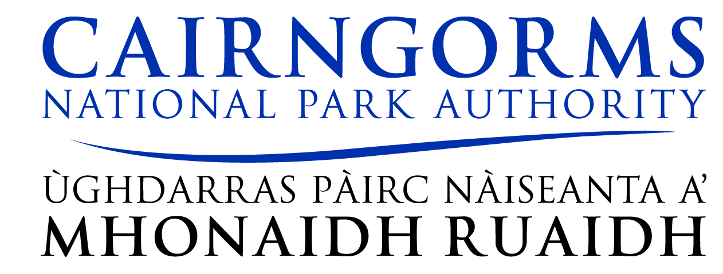

NOTICE OF MEETINGS

NOTICE is hereby given that the undernoted meetings will take place as follows:

Cairngorms National Park Authority Meetings

29th January 2016

To be held in: Community Hall, Boat of Garten

Finance and Delivery Committee 09.00am
Planning Committee 10.45am

Agenda and Papers for the Board meetings will be available for viewing on the Monday of the week of the meeting at the following office locations:

Cairngorms National Park Authority, 14 The Square, Grantown-on-Spey, Moray PH26 3HG, Tel: 01479 873535
Cairngorms National Park Authority, Ground Floor, Albert Memorial Hall, Station Square, Ballater AB35 5QB, Tel: 01339 753601 (Please telephone to make an appointment)

Aberdeenshire Council, Woodhill House, Westburn Road Aberdeen, AB16 GB, Tel: 01224 664221
Angus Council, Planning & Transport Division, County Buildings, Market Street, Forfar, DD8 3LG, Tel: 01307 461460

Highland Council, Council Offices, Ruthven Road, Kingussie, PH21 1EJ, Tel: 01540 664529
Moray Council, Keith Area Office, The Institute, Mid Street, Keith, AB55 5AH, Tel: 01542 885500
Perth and Kinross Council, Planning Offices, Pullar House, 35 Kinnoull Street, Perth, PH1 5DG

Also on the Park Authority website at www.cairngorms.co.uk

For any access or other requirements (e.g. Hearing Loop System) please contact the CNPA office in advance of the meeting

