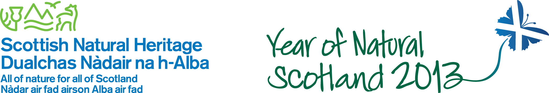
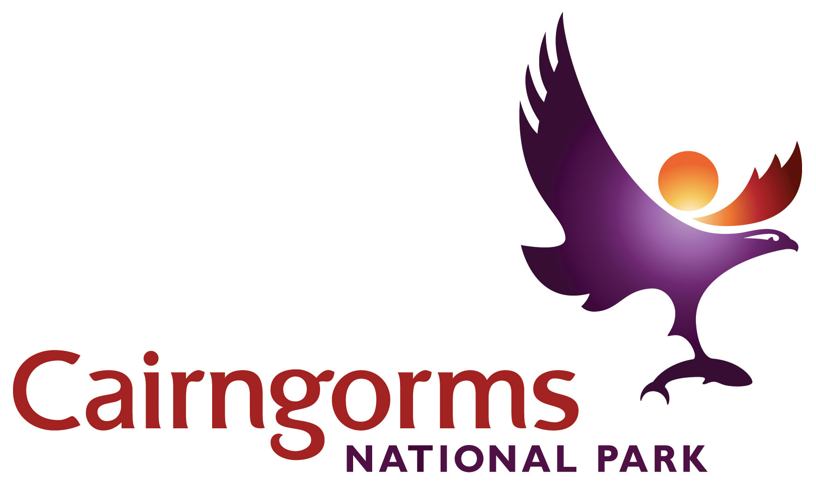

Cairngorms National Park
Outdoor LearningTravel Grant Scheme 2013/14
Evaluation form

- Visit details

School / Group name
Visit Location / site
Date of visit
Leader name
Ranger service / site staff support provided | Yes No
Number of students / group members |  | Age of students / group (approx)
Summary of activities undertaken including pre- and post-visit

- Learning Objectives

What were the learning objectives of your visit?

Were the learning objectives met? | Fully Partially Not at all

- Cairngorms National Park

Did you use any resources produced by Cairngorms National Park Authority to plan / support your visit? | Education packs (Abernethy / Muir of Dinnet)  ‘Getting Into’ Resource Pack  Cairngorms Learning Zone website  Cairngorms National Park website  Other – please detail
Did you find these useful? Please comment
Would you need any additional resources or training to achieve your learning objectives on a self-led visit to CNP? | Resources Training  Skills Other  Please specify

- About the travel grant scheme

How did you hear about the travel grant scheme?
What difference did the travel grant make?

Suggestions for improvements to the scheme

Thank you for completing this evaluation form. Your comments will help to inform future planning of the scheme.
Please send this form and copy of transport invoice to learning@cairngorms.co.uk or by post to Elspeth Grant, CNPA, 14 The Square, Grantown-on-Spey, PH26 3HG.

