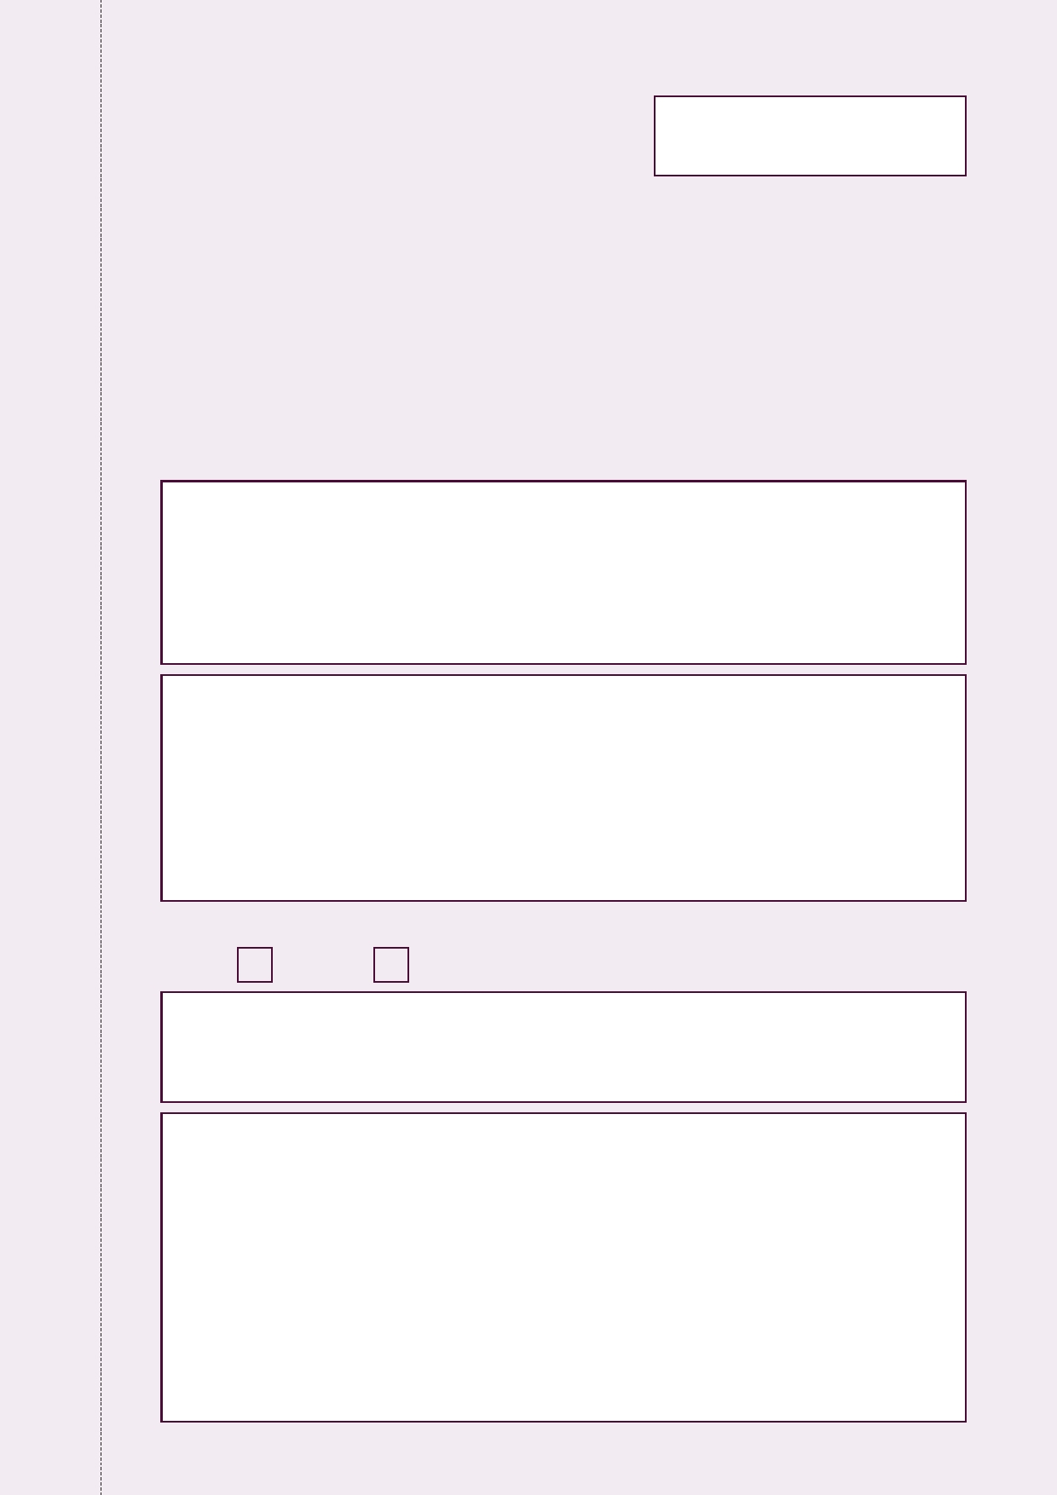
Cairngorms National Park Proposed Local Development Plan


Official Use Only
Reference:
Objection No:

Form for representations on the
Cairngorms National Park Proposed Local Development Plan

Please read the explanatory notes inside the front cover of the proposed Local Development
Plan before completing this form. The deadline for returning completed forms is 5pm, Friday 5
July 2013. The forms can also be completed online at www.cairngorms.co.uk. You can
photocopy this form, or further copies are available from the Cairngorms National Park Authority
offices or can be printed from our website.

Please use this form to state clearly the modification/s you would like to see made to the Plan. You should include the proposal/policy or paragraph reference where appropriate. Please use a separate form for each representation.

1. Name .......................................................................................................................................................................................
Address .......................................................................................................................................................................................
.......................................................................................................................................................................................
.................................................................. Postcode ..............................................................................
Telephone ........................................................................... Email ............................................................................

2. If you are representing a third party, please give their details.
Name ....................................................................................................................................................................................
Address ....................................................................................................................................................................................
.....................................................................................................................................................................................
.................................................................. Postcode .............................................................................
Telephone ........................................................................... Email ...........................................................................

To which address do you wish all correspondence to be directed? (please tick)

Own Agent

3. Please state clearly the policy, proposal, map or other aspect of the Plan or
guidance to which you wish to seek a modification.

4. Please state clearly and fully the grounds of your objection or representation
to the proposed Local Development Plan, using a continuation sheet if
necessary. (You are advised to limit your statement to a maximum of 2000
words, plus limited supporting materials).

Cairngorms National Park Proposed Local Development Plan


4. Continued

5. Please state clearly what change/s you wish to see made to the Plan, which would
resolve your objection.

Please return all completed forms to:
FREEPOST (RSHS-BHKL-KXHS)
Cairngorms National Park Authority
Albert Memorial Hall, Station Square
Ballater
AB35 5QB

Or email: localplan@cairngorms.co.uk

Forms should be returned no later than 5pm, Friday 5 July 2013.

After that date, you will be contacted be a representative of the Cairngorms National Park Authority with regard to your objections.

If you have any queries regarding completion of the comments form, or require further assistance, please contact the Development Plan team at the CNPA Ballater office: Tel: 013397 53601 Email: localplan@cairngorms.co.uk

www.cairngorms.co.uk

Data Protection
Details provided will only be used for purposes associated with the Local Development Plan. You may request to see personal information held by the CNPA at any time. Information will be shared with the Scottish Government Department of Planning and Environmental Appeals and may be published on our website. We will not publish address details but may publish the name of the person who has completed the form. By completing and submitting the form, you are consenting to the above.

