Newtonmore

Aerial of Newtonmore

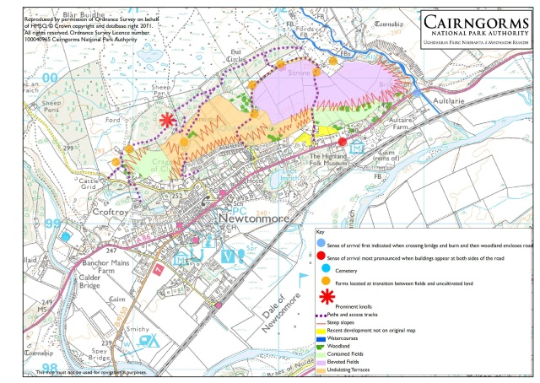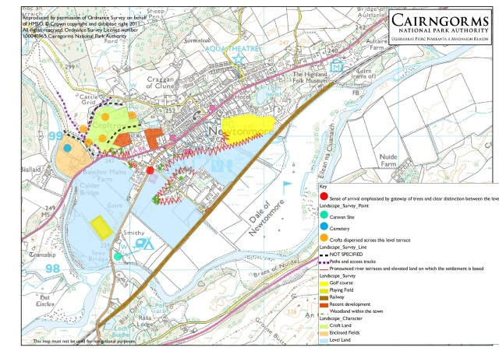

**Natural Landscape**

Newtonmore is surrounded by a blend of farmland, woodland, rivers and uplands, with views across the plain of the Spey to the mountains a few kilometres distant. The settlement is flanked by damp pastures close to the River Spey to the east and the fast-flowing River Calder and wooded Creag Dubh to the west.

Creag Dhubh is a prominent landmark overlooking the village. It is an outlier of the Monadhliath detached from the main range by the valley of the Calder. Its craggy outcrops are intrusive veins and sills of hard igneous rock, which have been plucked by the Spey glacier as it ground its way slowly towards the north-east. The hill is now richly wooded with birches and other native trees.

Creag Dubh is famous for its rock-climbing routes and sometimes a large frozen waterfall. It is also home to a herd of feral goats, and scanning from its ridges across Glen Banchor and towards Laggan, gives the possibility of seeing birds such as buzzards, peregrines falcons and golden eagles.

Beneath Creag Dubh lies Strathspey, a drainage line established nearly 400 million years ago (!) and subsequently deepened and straightened by glacial erosion.

Perhaps the main effect of glaciation in this area was the dumping of debris. The wet braes above Strone have a covering of heavy boulder clay and the slopes of the strath are stepped by rock benches, moraine ridges, and gravel terraces. Just east of the village a deep gorge carves through a substantial gravel fan left by meltwater, and out on to the haughlands of the Spey.

The village prides itself on a symbolic link to the Scottish wildcat (badge of the Clan MacPherson). Local wildcats will be largely unseen by residents or vistors, but the circular Wildcat Trail around the village does give the chance to see a range of natural features and wildlife, including this gorge, waterfall and many different kinds of trees.

The pastures close to the Spey are rich in wildflowers, including many kinds of orchids. Common sandpipers use the banks of the various river channels here in summer, and you might see dipper year-round.

**Historical Landscape**

**17th Century**

Though there is much archaeological evidence in nearby Glen Banchor and on the slopes behind the settlement, Newtonmore is neither a planned village, the site of an earlier township, nor the centre of a medieval estate. Instead it is located at the junction of the roads from Pitlochry and the Great Glen.

**18th century**

The building of new bridges over the River Spey in the late18th century at Ralia and Laggan enabled the re-routing of these two roads, so that the more intensively farmed lands on the south-facing slopes of Strath Spey could be better served.

**!9th Century**

However, the actual growth of Newtonmore did not begin until the 1860s. This was the result of the coming of the railway and the creation of a station to service the needs of the numerous rich estates to the west; the larger settlement of Kingussie served those to the east. Victorian villas set in grounds, one-and-a-half or two-storey retail and residential buildings, and terraced single-storey houses line the main road, particularly on the sunnier north side. Hotels at each end of the straight street are a reminder of the origins of this village and mark its extent c1900.

**20th Century**

By 1930 the village had doubled in size, a reflection of local requirements and the tourist trade. Initially this expansion was linear but more recently it has spread through the wooded slopes above the main street as well as across the flat ground south of the main street.

**The Values that People have for their landscape (this information is taken from responses to the community engagement questionnaires of 2010)**

* Newtonmore is valued as a traditional Highland village, a beautiful place where the scenery, wildlife and flora are all important. There is a feeling that people’s appreciation of this landscape often lacks any real connection to the land.
* People value the landscapes of the high hills and remote glens and have an affinity with the wider landscape of the strath as much as the village itself.
* Views from local roads, footpaths and the settlement were identified as being of highest importance and people would like to see these protected especially the views to the high Cairngorms.
* It is felt that the cultural heritage of the area is deteriorating with valued local landscape features such as veteran street trees, curling pond and dykes needing attention.
* Access around and within the settlement is valued especially routes that are off-asphalt and away from cars.
* Hanging baskets and winter lights are appreciated for the brightness/cheeriness they bring to the village landscape
* Particular mention is made of the Highland Folk Park.

**Landscape Priorities and Opportunities**

* Enhance opportunities for people to enjoy the richness of this landscape. Explore mechanisms for sharing information on the flora and wildlife of the area, especially that of the river Spey and its floodplain.
* Identify key views and ensure that wherever possible these are kept open for the enjoyment of all.
* Identify those individual features of the village landscape that are most valued and prioritise their maintenance and enhancement e.g. veteran street trees, dykes and familiar historic landmarks.
* Enhance the landscape quality, experience and interest along walking/cycling routes within and around the village and especially in areas where the settlement is expanding.
* Enrich people’s connection with the land through allotment provision and local history projects (possibly in connection with Highland Folk Park).