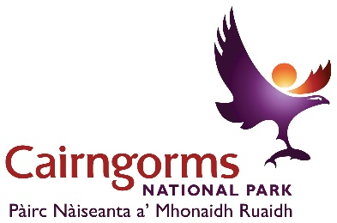
Above – Cairngorms National Park logo

Cairngorms National Park Partnership Draft Plan
Formal consultation – 23 September to 17 December 2021

Introduction to the formal consultation
After three months of informal consultation and over 500 individual responses, we've heard your views on everything from protecting endangered species to tackling climate change, securing more affordable housing and green public transport options, and providing meaningful jobs for the next generation of Cairngorms residents. Thank you to all of those who have already contributed to the consultation. We have used these views to help shape a draft plan, which will now be consulted on until 17 December 2021.
Responses have been many and varied, but one thing that is abundantly clear is that there has never been a more important to time to look at the future management of the Cairngorms National Park. The recovery from Covid-19, combined with the climate emergency and nature crisis, means that we need to look for new ways to address key issues in the Cairngorms. There is an opportunity for the Cairngorms National Park to lead the way in reaching net zero carbon emissions as fairly as possible, using nature-based and sustainable approaches to tackle the climate emergency, and putting people at the heart of decision-making.

The National Park aims
The Cairngorms is the UK’s largest national park at 4,528 sq km (6% of Scotland's land mass) and is home to one-quarter of the UK’s rare and endangered species. Around 18,000 people live in the Park across the areas of Aberdeenshire, Angus, Highland, Moray, Perth and Kinross, with two million visitors enjoying this special place every year.
The National Park has four distinct aims as set out by Parliament:
- To conserve and enhance the natural and cultural heritage of the area.
- To promote sustainable use of the natural resources of the area.
- To promote understanding and enjoyment (including enjoyment in the form of recreation) of the special qualities of the area by the public.
- To promote sustainable economic and social development of the area’s communities.
These aims are to be pursued collectively. However, if there is conflict between the first aim and any of the others, greater weight is given to the first aim (as set out in Section 9.6 of the National Parks (Scotland) Act 2000). This helps ensure conservation of the natural and cultural heritage underpins the economic, social and recreation value of the Cairngorms National Park.
The Partnership Plan embeds this approach in the strategy for the National Park that is approved by Ministers and sets the framework for all public bodies that work within the Cairngorms, from NatureScot and Local Authorities to Transport Scotland and Highlands and Islands Enterprise. It is also supported and delivered by a range of private and voluntary organisations.

What is a National Park Partnership Plan?
The National Park Partnership Plan sets out how all those with a responsibility for the Park will co-ordinate their work to tackle the most important issues. In particular, this plan:
- Sets out the vision and overarching strategy for managing the National Park.
- Guides the work of all public bodies and other partners to deliver the aims of the National Park.
- Provides the strategic context for the Local Development Plan.
- Sets out the Regional Land Use Framework and Regional Spatial Strategy for the National Park.
- Sets out the Economic and Sustainable Tourism Strategy for the National Park.
The document is arranged in three sections: Nature, People and Place. In each section we set out long-term objectives up to 2045 (the year Scottish Government has committed to achieving net zero), and these are supported by a set of policies and actions for the next five years. You can explore each of these sections below, or alternatively you can request a hard copy by emailing haveyoursay@cairngorms.co.uk or calling +44 (0) 1479 873 535.
We are aware that individuals reading the Partnership Plan will have different priorities; however, we would encourage you to read the plan as a whole to see how the four aims of the National Park will be delivered collectively. As an example:
To enable the target for peatland restoration to be met there will need to be a change to deer management in the Park. To enable the scale of peatland restoration to be delivered we will need to increase investment in skills and training of people to deliver this work, which in turn will be an opportunity for economic diversification within the Cairngorms economy. Finally, if we are going to have local contractors who undertake this work, we will need to have the right level of affordable housing that allows people to live and work in the area. In this way, all the long term objectives are interrelated, as the diagram below illustrates:

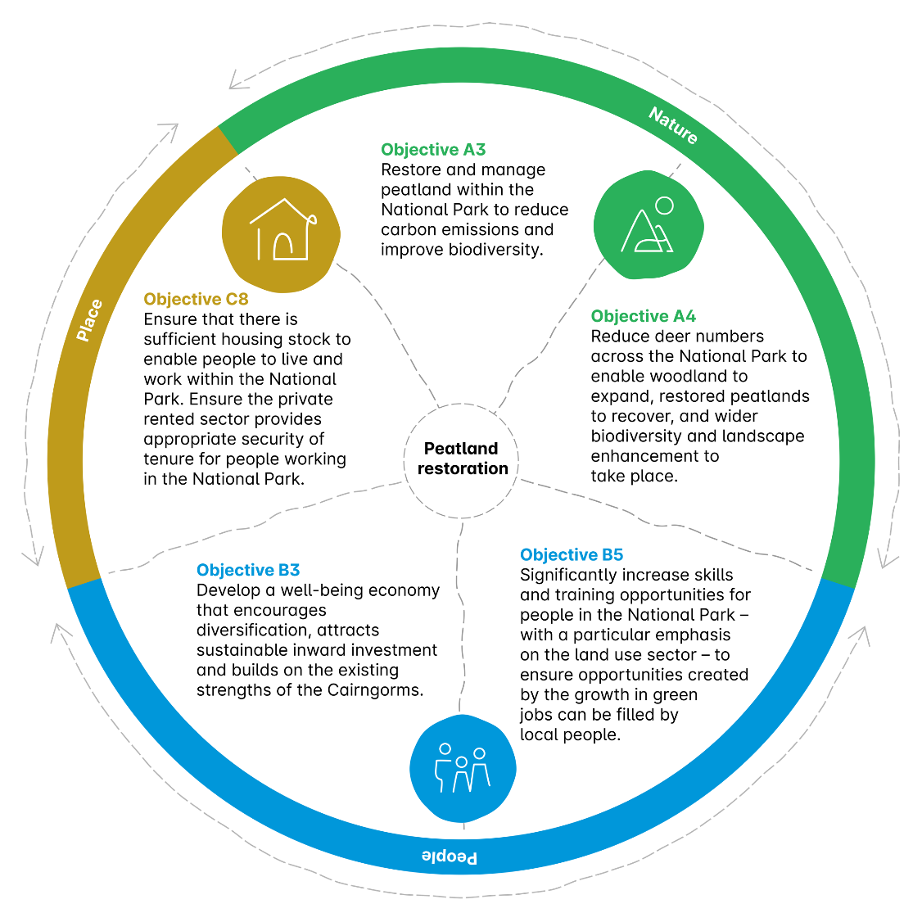
Above – diagram showing how multiple plan objectives overlap

The wider policy landscape
There has been significant changes in the policy landscape since the last Partnership Plan was published in 2017. A climate emergency and nature crisis have been declared, we have left the European Union and its policy framework, the Covid-19 pandemic and our collective need to recover from its impacts is at the forefront of policy discussion. And there is a desire to move to an economy that works for everyone, with citizen well-being at its heart.
Policies relevant to each of the long-term outcomes and objectives in this document are set out in the Policies section, but as a whole this is guided by the National Performance Framework and by the UN Sustainable Development Goals.
Finally, there will be changes to policy over the coming year that will be taken account of as the plan is developed. This includes the outputs from the UN climate change conference COP26 and the UN biodiversity conference COP15, National Planning Framework 4, Strategic Transport Projects Review 2 and other national policy developments.
The Cairngorms National Park also has a significant role to play in delivering the policy ambitions of Scottish Government. This is focused on Scotland being a place to innovate, trial new ways of thinking and show ambition to tackle the key challenges of our time. The National Park has done this in the past on issues like windfarm or hilltrack policy, on increasing the percentage of affordable housing up to 45% in certain villages and towns, and pursuing ambitious projects like Heritage Horizons.
Heritage Horizons is part of our plan to tackle the climate emergency, protect and enhance biodiversity, and deliver meaningful improvements to people’s health and well-being. The Cairngorms National Park Authority was successful in its £12.5 million bid to the National Lottery Heritage Fund’s Heritage Horizons Programme in July 2021, and the funding will support 22 projects across the Park over the next seven years. At the end of the Actions section, we set out how these projects link to the proposed long-term objectives of the Partnership Plan.

Striking the right balance
One of the key points around a management plan that takes a long-term view (in this case over 25 years and beyond) is the need to be honest and make clear that there will be trade-offs. The dial cannot be ‘turned up’ on everything. We will look for areas where we can deliver multiple benefits and mitigate impacts, but we will also be honest about areas where compromise will be required.
For example, the climate is changing and this will affect the species and habitats that can survive in the Cairngorms National Park. If we have more trees there may be a reduction in moorland species. Equally, it might not be possible – or indeed desirable – to get all features on designated sites into favourable condition if our collective goal is long-term ecological restoration. There may be a need for controls on holiday rental properties to ensure housing is affordable for local people.
These are all points of reasonable debate - and we have heard views from both sides in this consultation so far - but it is essential that we find the right path to ensure the National Park thrives for both nature and people in the future. This means having difficult conversations with people from all walks of life who care about the National Park and making important decisions – backed up by the best available evidence – for the long term.

Our long-term vision
‘An outstanding National Park, enjoyed and valued by everyone, where nature and people thrive together.’
The Cairngorms National Park has a long-term vision. It is the intention to keep this vision for the next Partnership Plan period as it provides a good summary of what we are collectively trying to achieve.
The final plan that will be developed after the consultation will set out the path to 2045 and what we need to do over the next five years to start making progress towards that. It is critical that people feed into this consultation so that we can build that picture of the future, together.
Nature
The interaction between people and nature is central to addressing many of the challenges we face in the National Park and in society more generally. There is a need to find solutions to the climate emergency that have nature at their centre and the Cairngorms National Park should be a rural exemplar of this approach. This means addressing the big land use and ecological issues in the National Park over the next 25 years that will also continue to have significant positive effects for the next 200 years.
The Nature section of this draft plan sets out the overall outcome we are seeking to achieve, alongside a series of long-term objectives for the National Park. These are supported by a detailed policy framework and a series of actions we plan to take over the next five years. You can explore the Nature section in more detail below, or alternatively you can request a hard copy by emailing haveyoursay@cairngorms.co.uk or calling +44 (0) 1479 873 535.

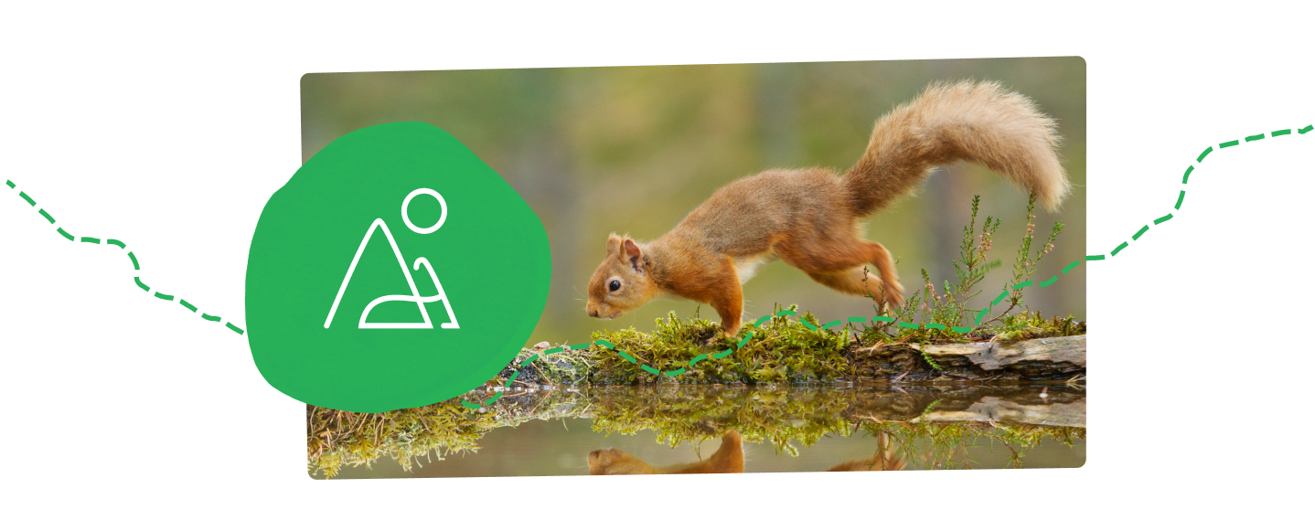
Above – photograph of a red squirrel on a mossy log next to water

Outcome: A carbon negative and biodiversity rich National Park with better functioning, better connected and more resilient ecosystems.

Objective A1: Ensure the Cairngorms National Park reaches net zero by 2045 at the latest and contributes all it can to helping Scotland meet its net zero commitments.
Target / indicator: Annual progress report on net zero for the Cairngorms National Park.
Why are we proposing this objective?: The climate crisis is the single biggest challenge that we face and it is critical that the Cairngorms National Park – as the largest protected area in the UK – is an exemplar in achieving net zero, a leader in nature-based solutions and in helping Scotland as a whole achieve its targets. The Park Authority is undertaking carbon baseline work for the National Park at present.
National policy context: Securing a green recovery on a path to net zero: climate change plan 2018–2032

Objective A2: Increase the amount of woodland cover in the National Park to ensure bigger, more natural woodlands, expanding up to a natural treeline, providing connections across river catchments and around the central core of the mountains. The majority of this will be native woodland and will be allowed to regenerate naturally, without the need for planting or fencing.
Target / indicator: A minimum of 35,000 ha of new woodland cover created by 2045.
Why are we proposing this objective?: It is important to place this increase in context. When we achieve these ambitious targets, over three quarters (77%) of the Park will still be open habitat by 2045.
The right tree in the right place increases the amount of carbon we can store, has biodiversity and landscape benefits, improves water quality and helps reduce the risk of flooding. This links directly to Scottish Government targets around net zero and biodiversity loss. There is also significant income potential for land managers from timber production and from the developing woodland carbon market (see objective A15). A move to more unfenced natural regeneration also has landscape, carbon and wildlife benefits.
However, there will still be a need for some direct tree planting and fencing in the Park, especially in the early years where numbers of deer and other species are still above a level that allows for natural regeneration.
National policy context: Securing a green recovery on a path to net zero: climate change plan, 2018–2032

Objective A3: Restore and manage peatland within the National Park to reduce carbon emissions and improve biodiversity.
Target / indicator: A minimum of 35,000 ha peatland restored by 2045.
Why are we proposing this objective?: Stops the loss of carbon, benefits biodiversity, improves water quality and helps alleviate flooding. Links to Scottish Government net zero and biodiversity ambitions. The carbon market for peatland restoration is developing fast and can potentially help to deliver this objective (see objective A15). The National Park has around 90,000 ha of degraded peat and 15% of the bare peat in Scotland.
National policy context: Securing a green recovery on a path to net zero: climate change plan, 2018–2032

Objective A4: Reduce deer numbers across the National Park to enable woodland to expand, restored peatlands to recover, and wider biodiversity and landscape enhancement to take place.
Target / indicator: Average red deer densities on the open range are five to eight per km² across the National Park by 2030. Sika and fallow deer (non-native species) will be contained within their current distribution in the National Park by 2030. Establish deer population in the woodlands of the National Park by 2025.
Why are we proposing this objective?: Average red deer densities on the open range are currently 11.5 per km2 across the National Park, but vary from four to 20 depending on location. To enable peatland and woodland work to proceed at the scale necessary to meet our targets, deer numbers will have to decrease in the National Park, with particular focus given to areas with high deer numbers. This is a complex picture and we will need to look at densities, occupancy and impacts on current and desired habitats, as well as impacts on estates and businesses.
There is also a need to address roe, fallow and sika populations in the Park and to control woodland deer numbers.
Both approaches are in line with findings of the Deer Working Group and Scottish Government’s response.
National policy context: Deer Working Group – Scottish Government Response

Objective A5: Reduce the intensity of game bird (grouse, pheasant, partridge) management within the National Park. Encourage lower density grouse shooting, as well as the adoption of best practice management techniques and sustainable pheasant and partridge shooting / releases.
Target / indicator: Average gamebird bags per unit area. Numbers of game birds released in the National Park.
Why are we proposing this objective?: The Grouse Moor Management Review (‘The Werrity Review’, 2020), and Scottish Government’s response to it, has indicated a move towards licencing grouse moors in the near future. This package of work will be the cornerstone of moorland management in the National Park.
There are significant releases of non-native gamebirds in the National Park, but information is patchy. There is a need to get a better handle on the data around these releases, to look at the impacts on native wildlife and to ensure a better regulated system.
National policy context: Grouse Moor Management – Scottish Government Response

Objective A6: Stop burning on deep peatlands (currently defined as greater than 50 cm depth) and licence burning on shallower peatlands to reduce carbon emissions and encourage natural regeneration. Reduce wildfire risk by ensuring wildfire action plans are in place.
Target / indicator: No muirburn on peatland soils of over 50 cm depth and burning on shallower peats regulated by licensing by 2023. Wildfire action plans cover the whole National Park by 2024.
Why are we proposing this objective?: Fires on deep peat can damage the peatland’s ability to store carbon and very intensive burning regimes on shallower peat soils reduce habitat diversity. Any muirburn in the National Park must be done in line with best practice.
Wildfires release carbon, can damage or destroy sensitive and rare habitats, can kill species and pose a significant risk to people and property. We will look to have clear wildfire action plans in place by 2024 and agree a position on the role of prescription burning as part of these.
National policy context: Grouse Moor Management – Scottish Government Response

Objective A7: Work with farms in the National Park to reduce their carbon footprint through improved management of grasslands and soil. Help join up habitats and ecosystems through increased woodland and scrub, restoring freshwater areas, and supporting a greater variety of species. Agree carbon and biodiversity management plans with farmers in the National Park to help guide activities.
Target / indicator: Carbon and biodiversity plans are in place for farms across the National Park by 2028.
Why are we proposing this objective?: A significant area of the National Park is farmed and, to achieve our net zero and biodiversity targets, we need to prioritise activity that reduces farming’s carbon footprint, enhances species diversity and builds resilience through joining up habitats and ecosystems.
Scottish Government has yet to set out its final approach to rural payments; however, it is committed to ‘the transition to a low carbon future, delivering a sustainable, productive, and profitable agricultural sector.’
There are also potential economic benefits to farmers through reduced input costs, for example using less fertiliser.
National policy context: A Future Strategy for Scottish Agriculture; Farmer-led Climate Change Groups Reports

Objective A8: Target rural payments to support sustainable food production, reduce carbon, increase and maintain the health of habitats and ecosystems, enhance biodiversity and help connect different habitats across the National Park. As part of this we will establish a Regional Land Use Partnership and Framework for the National Park which helps national and local government, communities, land owners and stakeholders work together to achieve net zero and find ways to optimise land use in a fair and inclusive way.
Target / indicator: Establish a Regional Land Use Partnership and Framework for the National Park by 2023.
Why are we proposing this objective?: Rural payments drive much of the farming activity in the Park. These payments are changing and can support farmers taking a coordinated approach to managing their land, delivering a range of public benefits (from carbon reduction to flood mitigation) in return for public support.
As the agriculture support framework develops, consideration will be given to what support is best at a national level and what could be devolved to a regional approach. This ties in strongly with the developing Regional Land Use Partnership approach.
National policy context: A Future Strategy for Scottish Agriculture; Agricultural Transition in Scotland

Objective A9: Restore and connect rivers to thriving wetlands and floodplains as part of a wider restoration of the National Park’s freshwater systems, helping mitigate the impacts of climate change.
Target / indicator: 75% of river systems are restored by 2045.
Why are we proposing this objective?: Natural freshwater systems improve water quality, help protect against flooding and store excess water, as well as providing essential habitats for wildlife in their own right.
National policy context: Water Framework Directive and River Basin Management Plans

Objective A10: Connect habitats and ecosystems across all different types of land use in the National Park to create an ecological network, which will bring wider landscape, biodiversity and people benefits.
Target / indicator: Establish an ecological network across the National Park by 2025.
Why are we proposing this objective?: Projects that work at a wider landscape scale deliver benefits over large areas and require new ways of working between multiple land managers, owners, agencies and anyone else with an interest in land. It is essential that woodland, moorland, farmland and other land uses in the National Park are managed in collaboration with one another to restore nature.
National policy context: Land use Strategy for Scotland - getting the best from our land: strategy 2021 to 2026; The Environment Strategy for Scotland

Objective A11: Enhance ecosystems across the National Park by increasing the area of land managed principally for their restoration.
Target / indicator: At least 50% of the National Park to be managed for ecosystem restoration by 2045.
Why are we proposing this objective?: The natural environment of the Cairngorms National Park is internationally significant, much of it being protected through European designations. Restoring ecosystems in the National Park will improve the resilience of those areas and deliver greater public benefits in the long term. At present around 30% of the Park is being managed for ecosystem restoration.
National policy context: Biodiversity Statement of Intent; The Environment Strategy for Scotland

Objective A12: Develop a more complete understanding of the National Park’s species, habitats and ecosystems, and help monitor progress over the long-term through a dedicated Cairngorms Nature Index.
Target / indicator: Develop and roll out the Cairngorms Nature Index by 2023.
Why are we proposing this objective?: A better understanding of species, habitats and ecosystems will allow for better, more targeted management of land within the National Park and will help deliver wider public benefits.
National policy context: Biodiversity Statement of IntentCairngorms Nature Index

Objective A13: Designated sites contribute to ecological network and ecosystem restoration.
Target / indicator: Designated sites contribute to ecological network and ecosystem restoration.
Why are we proposing this objective?: Our designated sites are intended to be the best examples of the rarest habitats and species in Scotland. As we face the twin challenges of the climate emergency and biodiversity crisis, their function and the way they are managed must also be focused on maximising the multiple benefits they can provide, including carbon storage and building resilience to climate change.
National policy context: Biodiversity Statement of Intent; Edinburgh Declaration on post 2020 biodiversity framework

Objective A14: Protect vulnerable species and ensure they get back on a sustainable footing, less reliant on targeted action and recovering within a network of habitats. Where necessary, reinforce existing populations and reintroduce lost species as part of a suite of measures to restore biodiversity in the National Park. Ensure species and habitat management adapts to a changing climate.
Target / indicator: Species Recovery Curve.
Why are we proposing this objective?: The number, variety and distribution of species will shift with the changing climate and with the changing landscapes of the National Park, including increased woodlands and restored peatlands. This will mean that different species may thrive in the future and that tough choices about species currently seen in the National Park may have to be taken. There is also a need to ensure that species that have been persecuted in the past are allowed to breed in the National Park across their range.
National policy context: Biodiversity Statement of Intent; Edinburgh Declaration on post-2020 biodiversity framework; National Species Reintroduction Forum

Objective A15: Attract private green investment into the National Park to fund nature’s recovery and share the benefits between communities, landowners, workers and wider society. Private finance will be as important as public money in funding nature’s recovery given the scale of the climate and biodiversity challenges we face.
Target / indicator: The Cairngorms National Park attracts a minimum of £250m of green finance for carbon and biodiversity projects by 2045.
Why are we proposing this objective?: Private green investment in carbon storage and management across the National Park, as well as to support positive management of habitats and their associated natural assets, could transform the rural economy of the Cairngorms. This is a relatively new market and there is a need to ensure the framework is in place for long-term benefit to the area and its people.
Private green investment (including the purchase of land) must deliver long-term benefits and these must be shared between communities, landowners, workers and wider society. It must also support a collective approach to managing the land, addressing a range of challenges alongside the climate emergency (a focus on carbon alone will not be sufficient to deliver multiple benefits).
National policy context: Securing a green recovery on a path to net zero: climate change plan, 2018–2032; Land Rights and Responsibility Statement

Objective A16: Work with farmers, estates and other land-based businesses to protect, manage and restore habitats and ecosystems across the National Park. Use ‘nature-based solutions’ to support a diverse economy that will be an exemplar for rural economies across the UK.
Target / indicator: The number of land-based businesses using nature-based solutions increases.
Why are we proposing this objective?: Land-based businesses are a key part of the National Park and there is an opportunity to demonstrate how nature-based solutions can contribute to a thriving rural economy, whilst also delivering for nature and our climate.
National policy context: A Future Strategy for Scottish Agriculture

Objective A17: Ensure a wider range of people are involved in, benefit from and support activities that protect and enhance nature and tackle climate change in the National Park.
Target / indicator: Conduct regular surveys on values and attitudes to nature restoration, land management and landscape change.
Why are we proposing this objective?: Without the involvement of a diverse range of people, the conservation and enhancement of nature in the National Park would not be possible. Tackling the climate emergency and nature crisis can only be done by taking people with us: local communities, workers in the rural economy, visitors and so on.
National policy context: Biodiversity Statement of Intent

People
The development of a well-being economy – where society and nature live in harmony, where people enjoy a fair distribution of resources and live in healthy and resilient communities – is central to ensuring that we have a National Park that works for everyone. It is crucial that the Cairngorms National Park continues to be a place where people can live and work and that young people have opportunities to stay and thrive.
There will be significant changes to the economy over the coming decade and we need to ensure that people have the skills that are needed for these changes. The communities of the National Park continue to play a central role, and we are committed to supporting their aspirations and delivering on their key priorities as part of this Partnership Plan.
The People section of this draft plan sets out the overall outcome we are seeking to achieve, alongside a series of long-term objectives for the National Park. These are supported by a detailed policy framework and a series of actions we plan to take over the next five years. You can explore the People section in more detail below, or alternatively you can request a hard copy by emailing haveyoursay@cairngorms.co.uk or calling +44 (0) 1479 873 535.

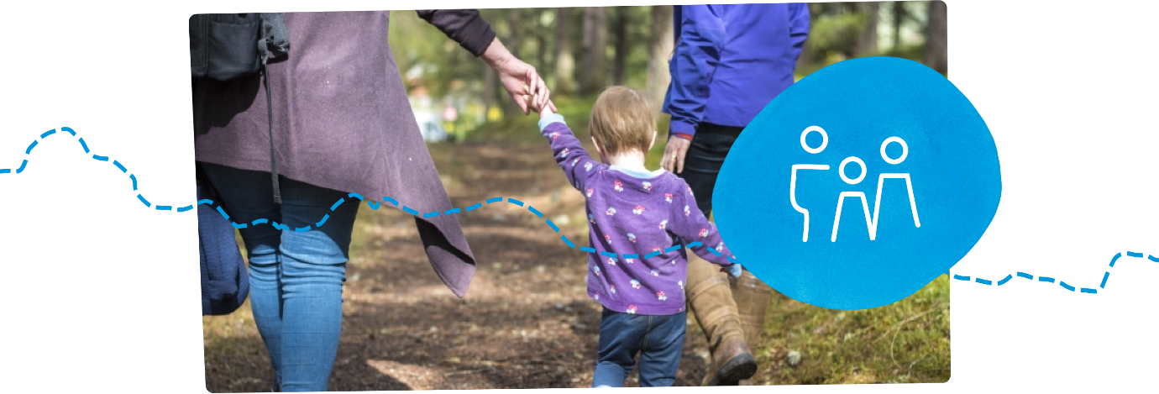
Above – Photograph of a young child walking through the woods with two adults

Outcome: A well-being economy that works for all the people of the Cairngorms.

Objective B1: Work to ensure the resident population of the National Park stabilises and reflects a diversity of backgrounds, enabling our communities to flourish.
Target / indicator: The overall population stabilises between 2020 and 2045.
Why are we proposing this objective?: A stable population that maintains a strong working age component (see objective B2) and is equal, diverse and inclusive will support thriving and sustainable communities and a successful local economy.
National policy context: A Scotland for the future: opportunities and challenges of Scotland's changing population

Objective B2: Work to stabilise or increase the proportion of young and working age people in the National Park relative to the total population.
Target / indicator: The proportion of young people and working age people in the National Park stabilises or increases between 2020 and 2045.
Why are we proposing this objective?: Young people are a key part of a sustainable population but require access to education, training, development, employment and housing in order to remain in (or indeed migrate to) the National Park. The need to ensure a strong working age population is also key to the delivery of many of the objectives set out in this plan.
National policy context: A Scotland for the future: opportunities and challenges of Scotland's changing population; Skills Action Plan for Rural Scotland

Objective B3: Develop a well-being economy that encourages diversification, attracts sustainable inward investment and builds on the existing strengths of the Cairngorms. Economic activity in the National Park is based on its special qualities; we will prioritise opportunities that provide year-round employment and well-being for communities across the National Park, as well as those that promote a circular economy, helping reduce waste and our wider impact on the environment.
Target / indicator: There will be a change in the percentage breakdown of different economic sectors within the National Park. Develop Cairngorms Cornerstone Indicators for a well-being economy. An increase in employee-owned or managed businesses in the National Park.
Why are we proposing this objective?: The development of a well-being economy is key for the Cairngorms. There is a need to move to an economic model that benefits people and nature, aiming for a more equitable distribution of wealth, health and well-being; promoting local expenditure and investment whilst protecting the planet's resources for future generations and other species.
There is also need for good quality jobs in the National Park that are less seasonal in nature. Overall this means building on existing strengths but looking for opportunities to help change the economy for the benefit of the people who live and work in the National Park.
National policy context: Growing the economy; Circular economy - Zero Waste Scotland

Objective B4: Increase the number of Living Wage employers in the National Park.
Target / indicator: The Park will have the highest proportion of Living Wage employers in rural Scotland by 2030.
Why are we proposing this objective?: The Living Wage is an indicator of quality of life, allowing people to access housing and other essential services. It is the only UK wage rate that is voluntarily paid by over 7,000 UK businesses who believe their staff deserve a wage which meets everyday needs – like the weekly shop, or a surprise trip to the dentist.
National policy context: Scottish Business Pledge

Objective B5: Significantly increase skills and training opportunities for people in the National Park – with a particular emphasis on the land use sector – to ensure opportunities created by the growth in green jobs can be filled by local people.
Target / indicator: There are an increasing number of apprenticeships within the National Park. An increasing number of people living in the National Park pass through skills training programmes for nature-based solutions.
Why are we proposing this objective?: The nature of many jobs will change in the National Park over the coming years as a low carbon economy is created. This means that there are opportunities for new jobs, but also that some traditional jobs in land use may evolve over time. There will also be a need to ensure that there are training opportunities to enter into expanding areas of traditional work like deer management, as well as the support to retrain as part of a ‘just transition’ (a shift to a greener economy where the benefits are shared as widely as possible).
National policy context: Just Transition Commission; Skills Action Plan for Rural Scotland; Nature-based Jobs and Skills Action Plan

Objective B6: Increase the area of land in the National Park that is in community ownership, or where the community is directly involved in its management.
Target / indicator: All major estates in the National Park involve communities in developing their long term plans by 2025, in line with Scottish Land Commission guidance. Increase the area of land in the National Park directly owned and managed by communities by 2030.
Why are we proposing this objective?: Increased community ownership and involvement in management of land will improve the delivery of public benefits to communities, supporting their health, well-being and the wider economy. This has been shown in places across Scotland where the community has become more involved in the management of land in which they live.
National policy context: Community Empowerment; Land Rights and Responsibility Statement

Objective B7: Empower individuals to make decisions about their local community through citizens’ assemblies and juries. Support community councils to become stronger local democratic bodies that plan for their local areas and allocate resources.
Target / indicator: Citizens’ assemblies and juries are established.
Why are we proposing this objective?: Citizens’ assemblies and juries will help empower local communities, build participation, and get them more directly involved in making decisions that affect their local area. This will include decisions on the delivery of services provided by the public sector.
National policy context: Community Empowerment

Objective B8: Support communities across the National Park to access funding for their community-led local development priorities and encourage community-led activities that help achieve priorities identified in the Partnership Plan.
Target / indicator: Community-led local development funding equivalent to at least 2014 (EU-based) programme levels is made available for distribution through a National Park-based governance mechanism.
Why are we proposing this objective?: We will maintain the Cairngorms Local Action Group’s excellent record of supporting community groups to realise their own local ambitions, while contributing at a community level to the collective priorities of the Cairngorms National Park Partnership Plan.
National policy context: Rural Economy and Communities policies (currently in development)

Objective B9: Increase the number of assets in community ownership and support the development of social enterprises that generate a profit within the National Park.
Target / indicator: The numbers of assets in community ownership or management triples from 2021. The percentage of community organisations’ income from social enterprises increases.
Why are we proposing this objective?: A foundation of a sustainable and resilient community is to have an asset that can be used and valued by the community. Where a social enterprise generates profit, other projects and services for the community can be supported.
National policy context: Cities and regions: community wealth building

Objective B10: Encourage greater use of Gaelic in the National Park.
Target / indicator: Increased opportunities for individuals and communities to engage with the language. More businesses and community groups using Gaelic in their promotional material.
Why are we proposing this objective?: Gaelic is part of the cultural and natural heritage of the National Park and has a vibrant part to play in its future. There is a need to support the continued use of Gaelic and maintain it is an active language and culture within the communities of the National Park.
National policy context: Scottish Government Gaelic Language Plan

Objective B11: Help improve the mental and physical health of the people of the National Park.
Target / indicator: The physical activity levels of the 25% least active National Park residents will have increased by 2030. Appropriate mental health indicator(s) to be identified and tracked over the course of the plan - we are seeking views on this metric.
Why are we proposing this objective?: As we all know, healthier individuals have an improved quality of life, and this in turn helps reduce the demands on our already stretched public health system. Preventative action at an early stage can have an impact on long-term public health outcomes, but we need a systemic change to how we address these issues. Through Heritage Horizons we believe the National Park can provide a rural exemplar in this area. There is also a need to ensure consistent public health messages, for example around issues like Lyme disease.
National policy context: Scotland’s Public Health Priorities; Mental Health Strategy

Objective B12: The visitor profile to the National Park will be more diverse, with a greater proportion of visitors from disabled groups, lower socio-economic backgrounds and minority and ethnic groups. Targeted support will be provided to programmes and projects that reduce inequalities for residents and visitors alike and help to make the Cairngorms ‘a Park for All’.
Target / indicator: The breakdown of visitors from Scotland to the National Park will more closely resemble the overall demography of Scotland. Increased participation from under-represented groups.
Why are we proposing this objective?: Anyone, no matter who they are, their beliefs or their needs should be able to visit and enjoy the National Park. There is also a need to provide targeted support across the National Park to ensure that programmes and projects contribute to reducing inequalities for residents and visitors alike.
National policy context: Scotland Outlook 2030 – Responsible Tourism for a Sustainable Future

Objective B13: Engage with people across the National Park through formal and informal education, increase the number of volunteer days spent caring for the National Park, and ensure that young people have a significant role in helping to manage the National Park.
Target / indicator: At least 200 volunteer rangers in the National Park by 2030. Increase the number of National Park volunteer days every year up to and including 2045. An increase in the number of John Muir Awards undertaken within the National Park.
Why are we proposing this objective?: Volunteering delivers tangible benefits to the management of the National Park, as well as to the physical and mental well-being of those participating in volunteering. It also provides excellent training opportunities and experience for future employment. There are currently around 36 volunteer rangers in the National Park.
National policy context: Volunteering for All: national framework
Place
Since its inception in 2003, the Cairngorms National Park has been most successful when a broad range of people come together to find the right solutions for their specific area. Over the next few years, there are a number of significant challenges around housing, transport and tourism that we need to address collectively. Finding the right solutions to make a significant difference for our residents and visitors will not be easy, particularly as we must do so with nature and climate at the heart of everything we do.
The work that has taken place already – such as increasing affordable housing provision to 45% in certain towns – is a step in the right direction; however, we now need more radical solutions if we are to truly deliver the desired objectives and outcomes.
The Place section of this draft plan sets out the overall outcome we are seeking to achieve, alongside a series of long-term objectives for the National Park. These are supported by a detailed policy framework and a series of actions we plan to take over the next five years. You can explore the Place section in more detail below, or alternatively you can request a hard copy by emailing haveyoursay@cairngorms.co.uk or calling +44 (0) 1479 873 535.

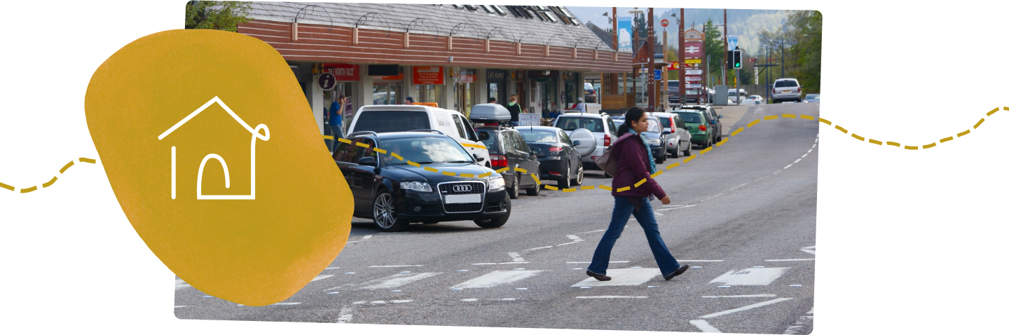
Above – Photograph of a woman crossing the road on Aviemore High Street

Outcome: A place that people want to live in, work in and visit that works for all.

Objective C1: Work to stabilise the growth in the number of people who visit the Cairngorms National Park during the peak season, while ensuring their enjoyment of the National Park and time spent here increases. The focus for any growth should be on the off-peak season and on those areas that have capacity to manage extra visitors.
Target / indicator: Overall tourism numbers and visitor days during peak season stabilise at around the current levels. Visitor satisfaction remains high and stable. Increase in off-peak visitor days.
Why are we proposing this objective?: Visitors to the National Park have increased from 1.3m to 2.1m since the National Park was established and there is increasing pressure on infrastructure and services during peak periods, as well as on the availability of housing for people working in the National Park.
Visitors will remain an essential part of the economy but the benefits need to be realised more widely and pressures eased, with more focus on the off-peak season.
National policy context: Scotland Outlook 2030 – Responsible Tourism for a Sustainable Future

Objective C2: Secure the National Park’s place as an international exemplar in sustainable tourism and the management of protected areas.
Target / indicator: The Cairngorms continues to hold the European Charter for Sustainable Tourism in Protected Areas.
Why are we proposing this objective?: The Sustainable Tourism Charter is a positive indicator that the management of the National Park is being undertaken in a sustainable way, in line with international standards of best practice.
National policy context: Sustainable Tourism - EUROPARC Federation

Objective C3: Encourage a transformative change in the way people get to and move around the National Park.
Target / indicator: 50% of journeys by visitors and residents within the National Park do not take place by car by 2030. 25% of visitors get to the National Park by public transport by 2045. E-bike hire and charging facilities will be available in all main settlements and major visitor hubs by 2030. People will be able to bring their own bikes to the National Park on all public transport by 2030.
Why are we proposing this objective?: How people get to and move around the Cairngorms is going to be one of the biggest changes in the National Park over the coming years. There is a need to improve public transport to cater for residents and visitors, and to move to a hub and spokes model (where one central ‘hub’ location caters for lots of smaller ‘spokes’) for key visitor destinations. There will be less use of private cars in future and a need to look at site-specific solutions for key areas of the National Park, such as Glenmore.
National policy context: National Transport Strategy

Objective C4: Improve path, cycle and access networks to be the best in Scotland.
Target / indicator: All communities are linked by safe off-road or segregated on-road routes suitable for all users by 2030. All core paths are in good condition.
Why are we proposing this objective?: The National Park already has some of the best path networks in Scotland. This will further enhance them and provide safe alternatives to the private car for local travel for both residents and visitors. This will contribute directly to improved public health outcomes. There is a need to ensure that the pedestrian environment in town and villages is safe and accessible.
National policy context: National Transport Strategy
Objective C5: Work closely with partners across the National Park to manage the impact of visitors and provide a high-quality experience. Ensure public infrastructure is of a high standard, able to cope with demand at key destinations, and consider how to best utilise areas of the National Park with capacity for increased visitor numbers.
Target / indicator: Number of public toilets, changing places toilets and campervan facilities within the National Park. Broadband and mobile connectivity in the National Park.
Why are we proposing this objective?: Good management for visitors increases capacity while reducing the impact of their visit. This in turn helps maintain the special qualities people come to enjoy within the National Park, including our local communities. There is also a need to ensure that the way we manage for visitors is linked in with the work on nature, especially around disturbance issues and to ensure we meet out climate targets.
National policy context: Tourism Declares initiative; Scotland Outlook 2030 – Responsible Tourism for a Sustainable Future

Objective C6: Provide outstanding opportunities to experience the natural and cultural heritage of the National Park via our promoted path network, while minimising disturbance to vulnerable species, habitats and sites.
Target / indicator: Maintain and improve key path condition and usage.
Why are we proposing this objective?: The walking and cycling routes within the National Park allow visitors and residents alike to enjoy the Cairngorms’ special qualities without having an adverse impacts upon them.
National policy context: Let's get Scotland Walking - The National Walking Strategy

Objective C7: Provide opportunities for everyone to experience and learn about the National Park’s outstanding historic environment, history and culture, with the Cairngorms being celebrated for its cultural heritage.
Target / indicator: Increasing number of cultural heritage projects promoted in visitor marketing.
Why are we proposing this objective?: The historic environment, history and culture of the National Park is a foundation of its communities and economy that is not always shared or valued sufficiently. There is also a key link between the culture and the natural environment, with people having such a significant role in the landscapes of the National Park. There are opportunities to develop the cultural heritage assets of the National Park as part of a move to a well-being economy.
National policy context: Our Place in Time - Historic Environment Scotland; Culture Strategy for Scotland

Objective C8: Ensure that there is sufficient housing stock to enable people to live and work within the National Park. Ensure the private rented sector provides appropriate security of tenure for people working in the National Park.
Target / indicator: A maximum of 15% of all housing stock in the National Park will be second homes, vacant or short-term let properties by 2040.
Why are we proposing this objective?: Access to affordable housing for people who live and work in the area has been an acute issue since the establishment of the National Park. The housing market in the Cairngorms requires urgent change to support local, essential housing for workers and young people. This cannot be addressed through house-building alone. There is a need to reduce the loss of existing properties to second homes and holiday lets. There is also a need to support specific housing for the ageing residential population of the National Park.
National policy context: Housing to 2040 strategy

Objective C9: Help resolve key worker and affordability issues with new housing in the National Park.
Target / indicator: 75% of new housing built is for social rental and / or mid-market rental and is directly linked to meeting the needs of local employers by 2030.
Why are we proposing this objective?: In order to provide access to housing for key workers and those on low incomes, new housing will need to be delivered for these groups in ways that have not been achieved before. There is a need to increase considerably the amount of housing that is affordable to those living and working in the National Park. There is also a need to identify housing specifically for holiday lets rather than as part of general housing allocations.
National policy context: Housing to 2040 strategy

Objective C10: Work with communities to ensure that the majority of land allocated for development around villages and towns in the National Park is controlled by communities or public bodies to help manage long-term development needs.
Target / indicator: The percentage of developable land in community or public body ownership is increasing.
Why are we proposing this objective?: Control of land is key to the delivery of developments that bring real public benefit to communities at the time and place they are needed. Whilst this objective proposes a major role for communities and public bodies in housing, private landowners and developers still have a significant part to play in delivering housing in the National Park.
National policy context: Housing to 2040 strategy

Objective C11: Take action to ensure villages and town centres in the National Park are thriving places where people live, shop and meet.
Target / indicator: The percentage of vacant properties on high streets of the National Park reduces.
Why are we proposing this objective?: Numerous opportunities and challenges have faced the town and village centres of the National Park for many years as shopping habits have changed. New businesses and activities will need to be supported to ensure these spaces continue to provide services and value to communities.
National policy context: A New Future for Scotland's Town Centres report
Consultation questions
We need your views on the future of the Cairngorms National Park. Please answer a few short questions below to give us your opinion on the draft partnership plan.

- To what extent do you agree or disagree that these are the right objectives and targets for the National Park?

- Why do you say that?

- Is there anything missing from the above list that you think we should prioritise?

- To what extent do you agree or disagree with the overall outcomes for nature, people and place we have proposed?

- Do you have any other comments?

You can submit your answers via our website at cairngormsviews.co.uk, by emailing haveyoursay@cairngorms.co.uk or calling +44 (0) 1479 873 535. If you would like a hard copy of the draft plan please phone, email or write to us at the below address and we will arrange this for you. Thank you for taking part.

Cairngorms National Park Authority
14 The Square
Grantown on Spey
PH26 3HG

