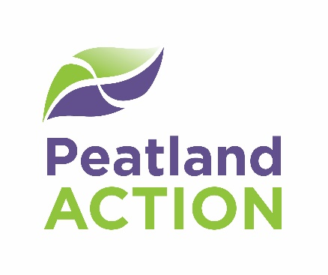

Peatland Restoration Expression of Interest (EoI)

The Cairngorms National Park Authority (CNPA) launched its grant scheme for peatland restoration projects in 1st April 2021. Please use this form to tell us about your proposed peatland restoration project. A member of our team will review your Expression of Interest as soon as we can, and will aim to contact you within 10 working days to discuss your project in more detail. If we are interested in working with you to develop a full application, we will send you further information about the grant application process and timeline for project delivery.

Your contact details

Name: | Phone No:
Email:
Organisation:
Role within organisation:
Address:

Eligibility criteria

The proposed restoration area lies within or partly within the Cairngorms National Park | ☐
I am the landowner/acting on behalf of the landowner with their consent | ☐
The proposed restoration area has peat soils over 30cm in depth and/or peatland habitats indicative of peat soils (a peat depth survey will be required prior to a grant being awarded) | ☐
Uninterrupted access for contractors will be permitted from 1st September to 31st March each year to allow for work to be completed | ☐
Access for site surveys, planning, and monitoring will be permitted all year round | ☐
I have read the CNPA Peatland ACTION grant Terms & Conditions | ☐

Project Title

Project Start Date: Estimated Completion Date:
Please note that where possible, we want projects to complete by 31 December to avoid the significant impacts of winter weather. Projects can run for up to 3 years.

Site Location
Six figure National Grid Reference (s)
Area, in hectares, of site(s):

Project Description:
Please describe your project clearly in 300 words or fewer (1/2 page A4). You should tell us about your project aims and objectives, the current land management, the site-based restoration activities you propose to carry out (if known), expected access routes and any potential constraints including land uses, access, designated sites, built heritage, protected species, site hazards, etc.

Current land Use

Stocking density/deer density in land holding:
Livestock Unit/ha; deer/km²:

Area to be restored (Hectares):

Value of funds being sought (if known) and potential match funding/in kind contribution:

Are you looking for multi-year funding for your project (s): Y/N
If so, please provide details:

Are the costs you are submitting to us:
☐ an outline estimate ☐ a firm quotation ☐ a full tender
☐ a single tender (accompanied with a justification)

Do you intend to seek private finance for your peatland restoration project, e.g. through the Peatland Code? The CNPA does not register projects for the Peatland Code, nor undertake the work needed for Code registration. Please provide details of advice sought to date.

Please email your completed Expression of Interest form to peatlandACTION@cairngorms.co.uk with the subject heading ‘Cairngorms Peatland Action – Expression of Interest’. You can submit an EoI at any time.

CNPA will collect and hold your contact details. We will use your details to help us assess your grant application. Please see our website for our Privacy Policy - Cairngorms National Park Authority.

Name: | Signature:
Role in organisation: | Date:

