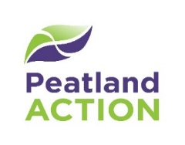
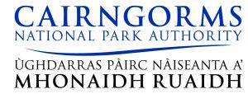
Expression of Interest – New Entrant Opportunity in Peatland Restoration
Background
The Cairngorms National Park Authority (CNPA) Peatland ACTION programme is working with landowners and contractors to restore degraded peatlands in the Cairngorms National Park. Restoring peatlands reduced carbon emissions, improves water quality and enhances biodiversity. The Scottish Government has committed £250 million to peatland restoration work over the next 10 years.
A lack of available contractors experienced in upland peatland restoration is a limiting factor in the amount of work that can be achieved each year. The CNPA Peatland ACTION team aims to increase local contractor capacity to deliver peatland restoration through offering opportunities for new entrants to learn techniques and gain experience.
This Expression of Interest (EoI) is for contractors to register their interest to deliver peatland restoration work within the Cairngorms National Park whilst receiving training on the appropriate techniques to use in the uplands. The work will focus on grip blocking and may include some erosion restoration techniques.
Eligibility
Contractors must be:
- Machine operators experienced working on peat with access to plant on low ground pressure tracks (maximum 14t) with ideally a tilt rotation hitch
- Willing to work closely with CNPA Peatland ACTION Officers to learn peatland restoration techniques
- Able to commit at least two machine operators and machines for at least four weeks continuous work in the Autumn / Winter and / or Late Summer / Autumn
Your details
Name/role:
Company name:
Company address:
Email address:
Phone number:
Machine operators experienced on peat / uplands:
List your machinery:
Brief note on why you are interested:

Please submit the EoI by email to PeatlandACTION@Cairngorms.co.uk. By submitting this EoI, you are consenting to being contacted by our team for the purpose of being invited to tender in competition with others.

