**Expression of Interest – Peatland Restoration Contractors**

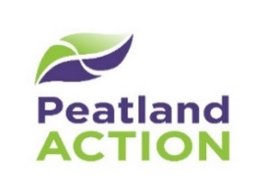

**Background**

The Cairngorms National Park Authority (CNPA) Peatland ACTION programme is working with landowners and contractors to restore degraded peatlands in the Cairngorms National Park. Restoring peatlands reduced carbon emissions, improves water quality and enhances biodiversity. The Scottish Government has committed £250 million to peatland restoration work over the next 10 years.

This Expression of Interest (EoI) is for contractors to register their interest to deliver peatland restoration work within the Cairngorms National Park.

**Eligibility**

Contractors must be:

* Machine operators experienced working on peat with access to plant on low ground pressure tracks (maximum 14t) with ideally a tilt rotation hitch
* Willing to work closely with CNPA Peatland ACTION Officers to deliver peatland restoration

**Your details**

|  |  |
| --- | --- |
| **Name/role:** |  |
| **Company name:** |  |
| **Company address:** |  |
| **Email address:** |  |
| **Phone number:** |  |
| **Machine operators experienced on peat / uplands:** |  |
| **List your machinery:** |  |
| **Brief note on why you are interested:** |  |

Please submit the EoI by email to [PeatlandACTION@Cairngorms.co.uk](mailto:PeatlandACTION@Cairngorms.co.uk). By submitting this EoI, you are consenting to being contacted by our team for the purpose of being invited to tender in competition with others.