`
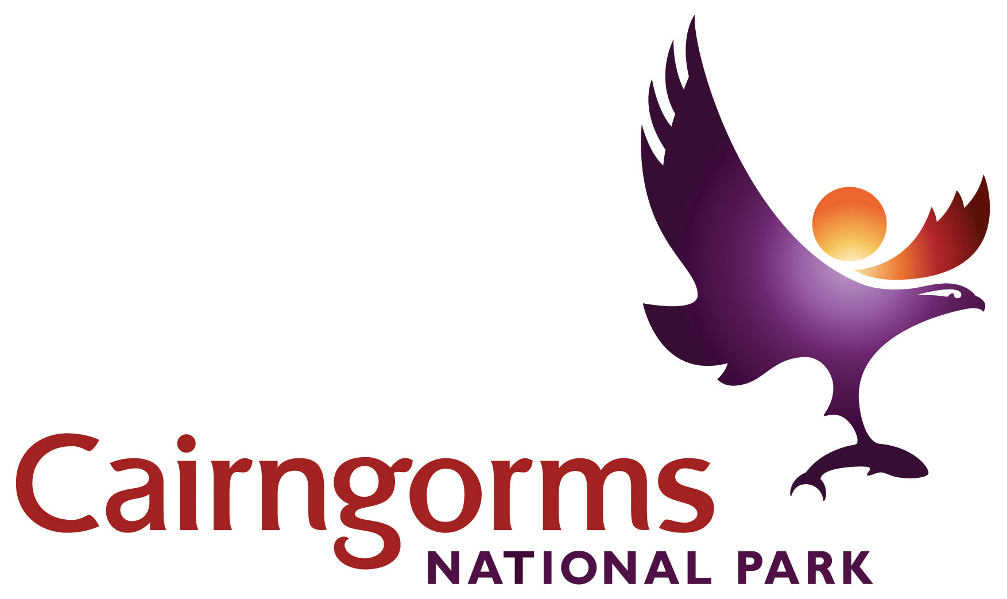

Cairngorms National Park
Outdoor Learning Travel Grant Scheme

Application Form

- SCHOOL/ GROUP INFORMATION
School/Group Name
Address
Post Code
Telephone Number
Contact email address
Teacher/Leader Name
Number of students/group members
Age of students/group members (approx)
Has your school/group visited the National Park before? |  | Yes No
If yes, when was this? |  | Insert year
Did they use a ranger service? |  | Yes No
Has your school received a CNP travel grant before? |  | Yes No

- SITE INFORMATION AND TRAVEL COSTS
Location of visit/ activities | see Guidelines for suggested sites  Include name of National Nature Reserve – see guidelines
Is Ranger Service or other staff support being provided for your visit? |  | Yes No
Name of the ranger service/site staff you have been in contact with?
Proposed date of visit
Estimated cost of transport, e.g. bus hire
Exclude VAT if you can claim it back

- CURRICULAR INFORMATION
If visit is not linked to the Curriculum, please skip to Section 4
Subject or Topic area to be studied (must have natural/cultural environment link)
Which particular areas of the Curriculum are you studying, linked to the visit? (Specific CfE contexts and content rather than just broad attainment outcomes)

How will your visit raise awareness and understanding of the Cairngorms National Park?

Would you be able to go on this trip without funding support? | Yes  No  Please comment

- NON-CURRICULUM LINKED VISITS
If section 3 was completed please skip to Section 5

Please tell us more about your group/clients.  (see Applicants section in Guidelines) | What is the make-up of your group?  What barriers or disadvantages does your group experience in accessing the National Park?
Please give a general outline of your planned itinerary
What would you like your group to learn/benefit from their trip to the National Park?

How will your visit raise awareness and understanding of the Cairngorms National Park?

Would you be able to go on this trip without funding support? | Yes  No  Please comment

- PAYMENT DETAILS

Please provide your bank details for payments to be paid direct to your account
Bank Sort Code |  | Account Number
Account Name

- SUBMITTING YOUR APPLICATION

Please send your completed application form:

By email to: learning@cairngorms.co.uk

By post to: Alan Smith, Outdoor Learning Officer, CNPA, 14 The Square,
Grantown-on-Spey, PH26 3HG

Confirmation of your application will normally be made by email.

Please remember you must apply for your grant and it must be agreed BEFORE your visit.

